**1**. IF first directory

ENTRY_CREATE: /path/Professor_Name

create project and create index.html according to template

**2**. IF not first directory

ENTRY_CREATE: /path/new_directoy

Add code on html inside folder above

<p>

<a href=“/new_directory/new_directory.html”></a>

</p>

And create new_directory.html according to template

**/\***

//**3**. IF directory contains archive with tag ;;Imagem;;

Upload image to html folder and Add code on html inside folder above

<td style="width:220px; height:220px;">

<img data-src=“;;Imagem;;selectedImage.jpg” class="img-thumbnail" alt=“Image could not be loaded.” >

</td>

//**4**. IF directory contains archive with tag ;;Texto;;

Add code on html inside folder

<td style="vertical-align:text-top;">

<p>TEXT INSIDE.</p>

</td>

**\*/**

**5**. IF

ENTRY_CREATE: /path/;;Imagem;;selectedImage.jpg

**5.1** Already has tag ;;Imagem;;

Do nothing on html codes, alert to user, but keep file there

**5.2** Does not have tag ;;Imagem;;

Do same as 3.

**6**. IF

ENTRY_CREATE: /path/;;Texto;;selectedImage.jpg

**6.1** Already has tag ;;Texto;;

Do nothing on html codes, alert to user, but keep file there

**6.2** Does not have tag ;;Texto;;

Do same as 4.

**7**. IF deleting directory

ENTRY_DELETE/path/random_directory

Remove code from html on the directory above

<p>

<a href=“/random_directory/random_directory.html”></a>

</p>

and delete directory /path/random_directory with everything inside

**8**. IF deleting ;;Imagem;;

ENTRY_DELETE/path/;;Imagem;;randomImagem.jpg

Remove code from 3., delete image from html folder look if there is another tag ;;Imagem;; inside the folder

If there is do same as 3.

if not do nothing else

**9**. IF deleting ;;Texto;;

ENTRY_DELETE/path/;;Texto;;randomText.txt

Remove code from 4. and look if there is another tag ;;Texto;; inside the folder

If there is do same as 4.

if not do nothing else

**10**. IF

ENTRY_CREATE: /path/;;Fornecer;;Any_file.extension

Upload the file to html folder and

Add

<p>

<a href=“Any_file.extension” style="color: #B22222” download>Any_file.extension download</a>

</p>

**11**. ENTRY_DELETE: /path/;;Fornecer;;Any_file.pdf

Delete the file from folder and remove code from 10.

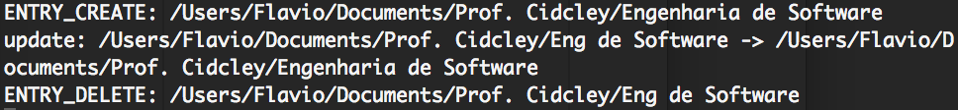

**12**. update: /path/oldDirectoryName -> /path/newDirectoryName

Delete newDirectoryName.html -> update in the project oldDirectoryName to newDirectoryName -> rename oldDirectoryName.html to newDirectoryName.html -> Change directory name on newDirectoryName.html -> change link destiny on the html of the folder above.

**13**. ENTRY_DELETE: /path/randomDirectory

Delete randomDirectory and remove code described in 2